Controcc Web automation script creation
Common structure:
- Level 1: TestingFrameWork: all common pagebase, configuration for the website
- Level 2: PageObjects: contain all screens of the website (typical in Selenium – easiest)
+ Inside page (inside an object):
- A folder name ‘Modals’ for all pop up appear in that page, note that inside a pop up there might be another pop up, all put in here
- A PageBase: a bridge to navigate to each tabs later
- Each tabs create a separate class
- A data file: create a class for all data
- Level 3: UITest: test cases in here
+ an appsettings file in here: which database, web url, browsers…
+ Test cases of one page put in a class: the class might be big if there are lots test cases in 1 page, but each test case can be run separated later
Run test 1: [SkippableTheory]
Run test 3 times: [RetryTheory(typeof(SkipException))]
Test script’s structure:
- Import libraries: using… (dark blue is Senelium’s library/API)
- Namespace: project name
- Public class: class’ name (unique) (this class contains all test cases of a whole function, for example, Payments function)
- Public void: test script’s name (unique)
+ green text: take from PageObject
+ light blue text: name in this test script
+ yellow: from common library (created in TestingFrameWork)
+ white: from common library (created in TestingFrameWork)
+ orange: text in ‘’
Field variants:
Button: ButtonElement
Text field: TextInputElement
title = new TextInputElement(this, "#titleTxt");
addAddress.Address1.SetValue("12 Manor Road");
subjectToMH117 = new CWebCheckboxElement(this, "#subjToMH117Chk-edit");
addAndEditContractPaymentMethodModal.AllowsNet.SetValue(false);
clientGroup = new CWebSelectElement(this, "#clientGroupDDL");
addDebt.TypeOfDebt.SetValue("Loan");
dateOfBirth = new CWebDatePicker(this, "#dateOfBirthDatePicker");
addDebt.DateOfValue.SetValue(new DateTime(2020, 08, 02));
gender = new CWebRadioGroup(this, "#genderRadio-edit");
closeStatementPage1.CloseStatementRadio.SetValue("On date");
(not sure) = new CWebSearchElement(this, "#");
addressList = new CWebListElement(this, "#addressList");
paymentTab.ContractPaymentMethodList.GetCellValue(1, "Allows net").Should().Be("Yes");
readyForAuthorisationTab.PaymentsList.SelectRow(1);
CWebListOfLinksElement: list contains links
Refresh browser: driver.Navigate().Refresh();
Add password (to authorise or finalise invoice/payment)
var credential = InitTestCredential();
confirmFinalisation.Password.SetValue(credential.Password);

Select rows:
- Select a row on the grid: readyForAuthorisationTab.PaymentsList.SelectRow(1);
- errorLog.ErrorLogList.SelectRowByCellValue("date", "31/07/2020 11:52:04");
- PaymentPeriodModalBase paymentPeriodModalBase = paymentTab.ContractPaymentMethodList.DoubleClickRow<PaymentPeriodModalBase>(0);
Log into HomePage:
HomePage homePage = NavigateToRelativeUrl<HomePage>("");
Login:
PaymentsPageBase paymentsPageBase = NavigateToRelativeUrl<PaymentsPageBase>("Payment");
FPReportsNavigator reportsNavigator = StartPage.FPHomeNavigator().GoToReports();
Log out and log in again:
LoginPage loginPage = orgDetails.Logout();
var credential = InitTestCredential();
HomePage homePage = loginPage.Login(credential.UserName, credential.Password);
Tool bar buttons/navigators:
NewDebtModal addDebt = fpDetailBase.Toolbar().CreateNewEntity<NewDebtModal>("Debt");
PageIsLoaded
public override bool PageIsLoaded()
{return ModalTitle.IsVisible() && ModalTitle.GetText().Equals("Confirm authorisation");} (this is for recognise text in the page – use modal title)
public override bool PageIsLoaded()
{return PageLoadedState(PromptText.GetBy());} (this is for recognise text in the message)
public bool PageIsLoaded() means: public Boolean (true – false, yes – no)
return PageLoadedState(RoleName.GetBy()); means: this RoleName is load is signal of the page has been loaded successfully

Click button/link:
- readyForAuthorisationTab.PaymentsList.PressButton<ConfirmAuthorisationModal>("Authorise"); (click button on a list)---open a modal, button belongs to a list
- paymentsCalculationConfirmationModal.ClickButton<SuccessfulPaymentsCalculationModal>("Yes");---click a button, close a modal
- homePage.Menu.Open<PaymentsCalculationConfirmationModal>("Tools:Calculate payments for all contracts");----open a modal, click to a link, link belongs to a list
- paymentsCalculationConfirmationModal.YesCalculationButton.Open<SuccessfulPaymentsCalculationModal>();---another method to use Open
- successfulPaymentsCalculationModal.OkButton.Click(); ---click a button, close a modal
- readyForFinalisationTab.PaymentsList.PressButton("Unauthorise"); --click a button (that belongs to a list) and don’t open a modal
Double click:
PaymentPeriodModalBase paymentPeriodModalBase = paymentTab.ContractPaymentMethodList.DoubleClickRow<PaymentPeriodModalBase>(0);
Move to be another tab:
- PaymentTab paymentTab = contractPageBase.GoToTab<PaymentTab>(ContractPageTabs.Payment);
Assert:
fpDebtDetail.AmountOutstandingList.GetCellValue(1, "Date").Should().Be("09/08/2020");
fpDebtDetail.AmountOutstandingList.GetCellValue(1, "Value").Should().Be("£150.00");
paymentItemModalPaymentTab.Type.GetText().Should().Be("Cost");
auditTrail.HeaderText.GetText().Should().Contain("Changes for FP Common Account");
contactDetails.ContactRolesList.RowIsPresentInList("roles-headname", "Court of Protection-value").Should().BeTrue();
downloadSuccess.Should().BeTrue();
readyForFinalisationTab.PaymentsList.IsVisible().Should().BeFalse(); (assert none displayed in the list)
Go to page from Search:
SearchNavigator searchFor = StartPage.FPHomeNavigator().GoToSearch();
searchFor.Entity.SetValue("Contacts");
searchFor.More.Click();
searchFor.ContactName.SetValue("Smith");
searchFor.ContactRole.SetValue("Appointee");
searchFor.Search.Click();
FPContactDetailsTab fpContactDetails = searchFor.SearchResults.SelectRowByCellValue<FPContactDetailsTab>("name", "Smith, Fred");
Search and synchronise
FPDetailBase fpDetailBase = allClientAccounts.FPHomeNavigator().GoToClients().GoToClientUsingFullSSRef("JJ001");
FPClientNavigator clientNav = fpDetailBase.Toolbar().SynchroniseClientAndNavigator();
Select from left navigator:
FPReportsNavigator reportsNavigator = StartPage.FPHomeNavigator().GoToReports();
FinancialProtectionStatementsReport fpStatementsReport = reportsNavigator.ChooseReport<FinancialProtectionStatementsReport>("Financial Protection Statements");
Wait time:
driver.Wait = new WebDriverWait(driver, new TimeSpan(0, 0, 90));
Thread.Sleep(1000);
Method to expand the use of the existing method (the second one inherits from the first one):
public TPage ChooseDictionary<TPage>(string dictionaryName) where TPage : PageObjectBase, new()
{ExpandAll.Click();
LinkElement dictionaryLink = new LinkElement(this, dictionaryName);
TPage page = dictionaryLink.Click<TPage>();
page.Driver = Driver;
return page;}
public CWebDictionaryBase ChooseDictionary(string dictionaryName)
=> ChooseDictionary<CWebDictionaryBase>(dictionaryName);

Date time
addNotification.Date.SetValue(new DateTime(2022, 12, 20));
notificationsIssued.From.SetValue(DateTime.Now.AddDays(-7));
notificationsIssued.To.SetValue(DateTime.Now.AddDays(7));
MessageDisplayedFrom.SetValue(DateTime.Today.AddDays(-2));
MessageDisplayedTo.SetValue(DateTime.Today.AddDays(2));
EffectiveDate.SetValue(DateTime.Today);

Xpath/CSS
CSS example:
reportTitle = new LabelElement(this, "span[style*='font-size: 16pt;']", SelectByEnum.CSS);
saveBtn = new ButtonElement(this, "footer > #save_btn", SelectByEnum.CSS);
saveBtn = new ButtonElement(this, ".slds-button_brand:not(.slds-is-disabled)", SelectByEnum.CSS);
(this Save button is on New Payee Detail modal, Contract/CPM)
.slds-card .list (.slds-card is first part of class name, list is a class name)
h1.slds-page-header__title (h1 is a tag name, slds-page-header__title is first part of class name)
.wizard__content * div (wizard__content is class name, div is tag name)
[data-uitesting-id='M: Ends'] + button (button is a sibling-element-tag right after ‘M: Ends’ element
[data-uitesting-id='readyForFinalisationList'] ~ div [data-uitesting-id='Total VAT']: div is any sibling of [data-uitesting-id='readyForFinalisationList'], and [data-uitesting-id='Total VAT'] is a child inside div
[data-uitesting-id='M: List']:has([data-uitesting-id='M: Include deleted']): return a List that includes ‘Include deleted’
div:has(>[data-uitesting-id='Test']): select an immediate div parent of data-uitesting-id='Test'
div:has(+[data-uitesting-id='Test']): select an immediate div older sibling of data-uitesting-id='Test'
div:has(+.ag-cell-value) input: ‘div’ is immediate older sibling of class ‘ag-cell-value’. ‘input’ is any child of ‘div’
In CSS: Use a white space to match all descendants of an element, The asterisk * matches any element.
There are four different combinators in CSS:
- descendant selector (space)
- child selector (>)
- adjacent sibling selector (+) (adjacent = immediately)
- general sibling selector (~)
More in: https://www.w3.org/TR/selectors-4/
Method to use CSS selector better:
// Helper function to find checkbox within form
// Assumes neither group/control data-uitesting-ids contain single quotes
CWebCheckboxElement checkboxInGroup(string groupName, string controlLabel, int modalLevel = 1)
{string modalStub = modalLevel >= 1 ?
"M" + (modalLevel > 1 ? modalLevel.ToString() : string.Empty) + ": "
: string.Empty;
return new CWebCheckboxElement(
this, $"[data-uitesting-id='{modalStub}{groupName}'] [data-uitesting-id='{modalStub}{controlLabel}']", SelectByEnum.CSS);
------
If you just want to select the second <a> element regardless of what other types of elements there are in your <li>, use this selector:
.container li a:nth-of-type(2)
If your <li> will only have exactly 2 <a> elements, you can use the general sibling combinator ~ for bonus IE7/IE8 support:
.container li a ~ a }

Xpath example:
https://www.brainkart.com/article/XPath--Operators,-Special-Characters-and-Syntax_8668/
https://www.w3schools.com/xml/xpath_syntax.asp
Asterisk (*): is a Wildcard character. An asterisk in XPath may represent any node or attribute name of XML or DOM. A node is a tag in XML document. When we do not bother about node or attribute name we can use an asterisk.
//input[@*=’demo’] -> Any “input” node which contains an attribute value as “demo” for any attribute.
//a[@*] -> Any ‘a’ node which contains any attribute
//a[contains(@*,’demo’)] -> Any ‘a’ node of which any attribute value contains “demo”.
//h4[text()='Organisation']/following-sibling::div/div[@role='radiogroup']: Selects all siblings after the current node
//legend[contains(.,'Export details')]/following::button[starts-with(@data-uitesting-id, 'Save')]: Selects everything in the document after the closing tag of the current node
//h2[contains(.,'service level')]/../..//input[starts-with(@data-uitesting-id, 'M:')]
static string multiSelectButtonXPath(string label)
=> $"//div[contains(@class, 'multi-select')]//*[contains(@class, 'slds-form-element__label')][text()='{label}']/following-sibling::*//button[starts-with(@data-uitesting-id, 'M:')]";
//span[contains(.,'Type:')]/following-sibling::*[1]: select immediate sibling of span Type
selectClientGroup = new ButtonElement(this, multiSelectButtonXPath("Client groups"), SelectByEnum.XPath);
//span[contains(.,'Starts on')]
//div[contains(@class, 'list')][starts-with(@data-uitesting-id, 'M2:')]
following::*button[starts-with(@data-uitesting-id, 'M: OK')]
//p[contains(.,'Delivery')]/following-sibling::*//button
$"//span[contains(text(), '{linkText}')]/../../../preceding-sibling::span": if want to select the immediate older sibling, it will be preceding-sibling::span[1]
//p[contains(.,'Delivery')]/following-sibling::*//button/parent::div
//p[contains(.,'Delivery')]/following-sibling::*//button/ancestor::div
//input[@id='id' and @value='value1' or @value='value2']

- Xpath of tab: tabs = new CWebTabsElement<PaymentPeriodModalTabs>(this, "tablist_undefined", SelectByEnum.Name);
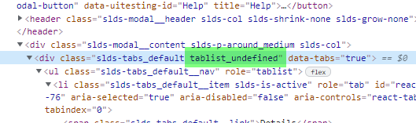

WAIT in Selenium
https://www.selenium.dev/documentation/webdriver/waits/
Example: (wait for the button to be visible before clicking => Explicit wait)
public void DownloadReport()
{
var div = Driver.Wait.Until(condition =>
{
IWebElement button = condition.FindElement(By.CssSelector("[data-uitesting-id='Download']"));
return button.Displayed;
});
DownloadButton.Click();
}

Implicit wait:
An implicit wait is to tell WebDriver to poll the DOM for a certain amount of time when trying to find an element or elements if they are not immediately available. The default setting is 0. Once set, the implicit wait is set for the life of the WebDriver object instance.
driver.manage().timeouts().implicitlyWait(10, TimeUnit.SECONDS);

Expicit wait
An explicit waits is code you define to wait for a certain condition to occur before proceeding further in the code. The worst case of this is Thread.sleep(), which sets the condition to an exact time period to wait. There are some convenience methods provided that help you write code that will wait only as long as required. WebDriverWait in combination with ExpectedCondition is one way this can be accomplished.
WebDriverWait wait = new WebDriverWait(driver, 10);
WebElement element = wait.until(
ExpectedConditions.visibilityOfElementLocated(By.id("someid")));

F

Get title of a page
var reportTab = driver.WindowHandles[1];
string reportTitle = driver.SwitchTo().Window(reportTab).Title;
reportTitle.Should().StartWith("Carer assessment report");

public static void InsertUnprocessedMessages()
{
var dbConfig = TestConfigurationManager.DatabaseConfiguration;
string database = dbConfig.DatabaseName;
var conn = new SqlConnection(getConnectionString(database));

void runSQLOnCurrentDb(string sql) => runSQL(conn, $@"USE [{database}]{sql}");

runSQLOnCurrentDb(@"Declare @XML1 XML = '<Root User=""OCCLAN\fullweb"" Date=""2022-04-21T08:00:00.123"" Username=""''AutoTest01''""/>',
@XML2 XML = '<Root User=""OCCLAN\fullweb"" Date=""2022-04-21T08:00:00.123"" Username=""''AutoTest02''""/>'
Set Identity_Insert dbo.TSys_QueueError On
Insert Into dbo.TSys_QueueError(QueueErrorID, MessageTypeName, MessageBody, ErrorDate, QueueName)
Select 23, 'http://www.oxfordcc.co.uk/ContrOCC/Auditing/ChangeUserPassword', Cast(@XML1 As Varbinary(Max)), dbo.GetDate(), 'ContrOCCAuditingTarget' Union All
Select 24, 'http://www.oxfordcc.co.uk/ContrOCC/Auditing/ChangeUserPassword', Cast(@XML2 As Varbinary(Max)), dbo.GetDate(), 'ContrOCCExceptionsTarget'
Set Identity_Insert dbo.TSys_QueueError Off"); }

Example of FOREACH loop
Site: https://learn.microsoft.com/en-us/dotnet/csharp/language-reference/statements/iteration-statements

private IWebElement getCellByColumnAndValue(string headerName, string value)
{try
{var wrapper = OwnerPage.Driver.FindElement(GetBy());
var bodyList = wrapper.FindElement(By.ClassName("ag-center-cols-container"));
var cells = bodyList.FindElements(By.ClassName("ag-cell-value"));
foreach (var cell in cells) //used in cases of FindElements
{var colID = cell.GetAttribute("col-id");
if (colID != null && colID.ToLower().Split("_")[0].Equals(headerName.ToLower().Replace(" ", ""))
&& cell.Text.ToLower().Equals(value.ToLower()))
{return cell;}}}
catch (Exception) { }
return null;}

From Chloe:
To set up private Jenkins Controcc Web Integration tests
Notes:
- All of the jobs are copied from the view of the version you branched from (xx.x)
- The convention is that private Jenkins jobs should be in the appropriate view and the name should start with your initials.
- Make sure you are logged in, you won't be able to create Jenkins jobs without being logged in.
Instructions:
- Copy the "xx.x L0 - Core - Get Artifacts" jenkins job.
  - Configure the "Branch Specifier" (under "Pipeline" "Definition" "SCM" "Branches to build") to be the name of your private branch (it should be replacing vxx.x/develop)
- If the version you branched from was "xx.x.0", this can be done for other versions, but is not necessary.
  - Copy the "xx.x L0 - ControccWeb - Upgrade Database" Jenkins job
    - Configure the "Branch Specifier" (under "Pipeline" "Definition" "SCM" "Branches to build") to be the name of your private branch (it should be replacing vxx.x/develop)
    - Configure the default value of the "upstreamJob" string parameter to be the name of your get artifacts Jenkins job.
    - Configure the "Projects to watch" (under "Build Triggers", "Build after other projects are built") to be the name of your get artifacts Jenkins job.
- Copy the "xx.x L0 - ControccWeb - Patch Database" Jenkins job
  - Configure the "Branch Specifier" (under "Pipeline" "Definition" "SCM" "Branches to build") to be the name of your private branch (it should be replacing vxx.x/develop)
  - Configure the default value of the "upstreamJob" string parameter and the "Projects to watch" (under "Build Triggers", "Build after other projects are built") to be
    - The name of your upgrade jenkins job, if you created one.
    - The name of your get artifacts Jenkins job if you did not create an upgrade job.
- Copy the "xx.x L1 - ControccWeb - Run Chrome Integration Tests" Jenkins job (or the Controcc web integration test of your choosing)
  - Configure the "Branch Specifier" (under "Pipeline" "Definition" "SCM" "Branches to build") to be the name of your private branch (it should be replacing vxx.x/develop)
  - Configure the "dataSourceJob" (in the default value of the "jsonTestConfig" string parameter) your patch Jenkins job.
  - Configure the "Projects to watch" (under "Build Triggers", "Build after other projects are built") to be the name of your patch Jenkins job.

From Chloe: How to create a develop build as a private job on Jenkins
You will need to be logged in.
Go to the private view on Jenkins for the branch e.g.
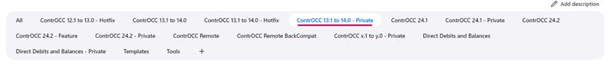
Then click "New Item" on the left
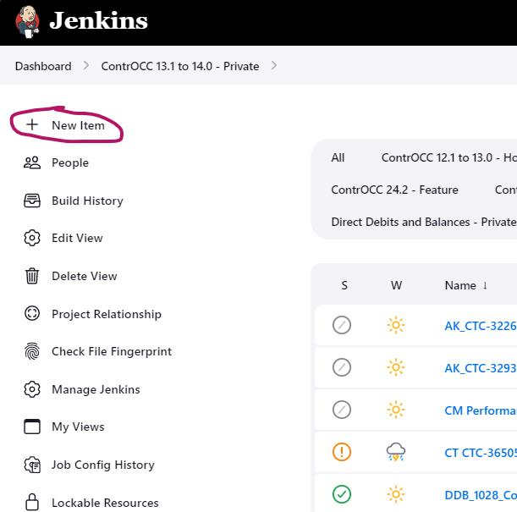
Give your job a name, it should start with your initials, for example
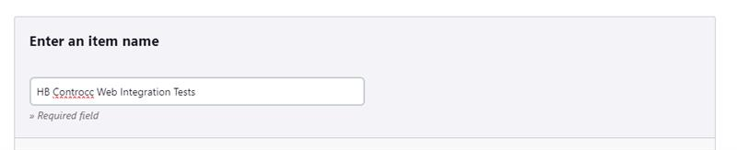
Scroll to the bottom, and enter the name of the controcc web integration tests job you want to copy
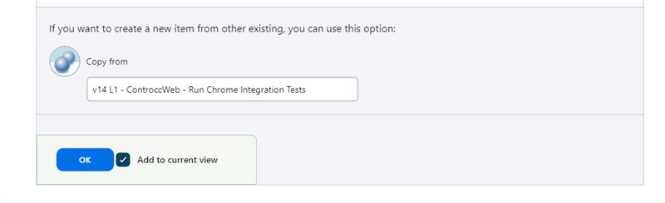
Click OK. Then scroll down to the jsonTestConfig parameter and edit the testName to be the test you want to run.
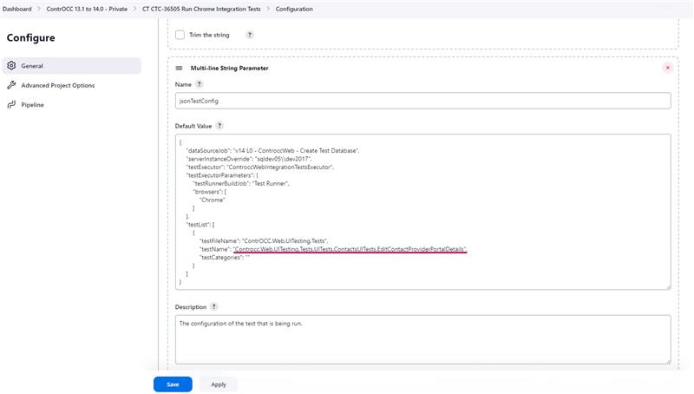
Like this:
{
"dataSourceJob": "24.2 L0 - ControccWeb - Patch Database",
"testExecutor": "ControccWebIntegrationTestsExecutor",
"upstreamBackupSourceKey": "CW",
"testExecutorParameters": {
"testRunnerBuildJob": "24.2 L0 - Core - Run Installation Tools Build",
"browsers": [
"Chrome"
]
},
"testList": [
{
"testFileName": "ContrOCC.Web.UITesting.Tests",
"testName": "Controcc.Web.UITesting.Tests.UITests.SystemAdminUITests.ConnectAdministration_DataRetention",
"testCategories": ""
}
]
}
Then move to Throttle configuration and remove tick of any checkboxes under Multi-Project Throttle Category:
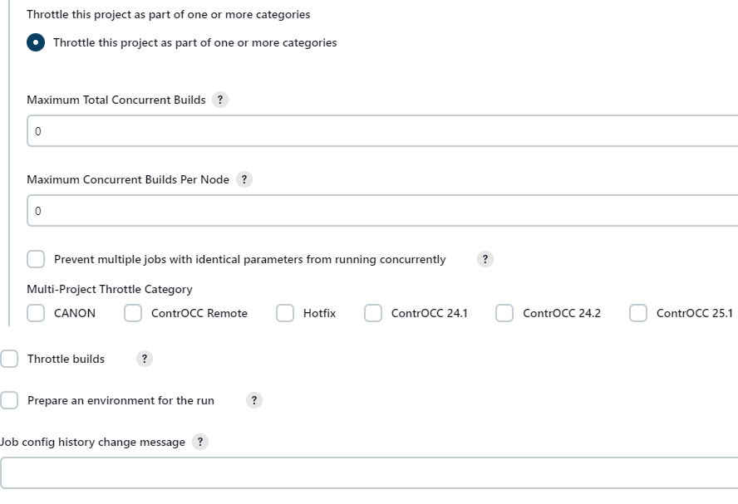
Save, and you have a test ready to run.

Change repo location on Visual studio Code using Git bash
First go to Controcc location on the machine, e.g. C:\ContrOCC\ContrOCC
Right click anywhere in the folder and select ‘Show more options’
The click ‘Open Git Bash here’, you will then have this screen:
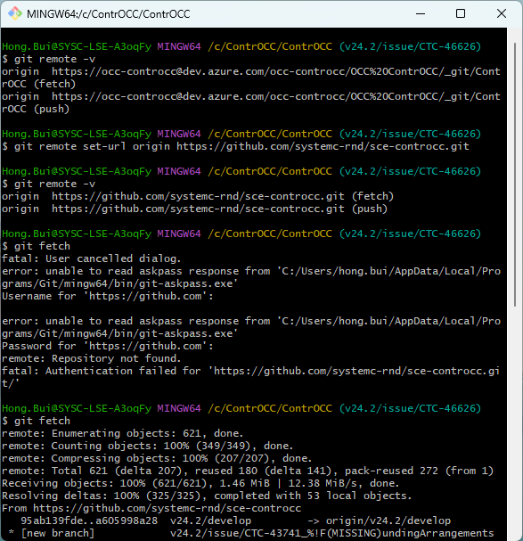

Documentation for installing Jenkins: https://www.jenkins.io/doc/book/installing/windows/ there are also links to other aspects of Jenkins
Some useful plugins:
- Git | Jenkins plugin, used to checkout the code
- Dark Theme | Jenkins plugin, just for visuals
- Job Configuration History | Jenkins plugin, useful for looking back at old config
- If you want to use a groovy pipeline:
  - Pipeline | Jenkins plugin - documentation for syntax and structure can be found Pipeline Syntax
- If you want to just use free style job configuration (probably simpler to set up):
  - MSBuild | Jenkins plugin
  - PowerShell | Jenkins plugin
  - MSTest | Jenkins plugin
  - JUnit | Jenkins plugin
  - xUnit | Jenkins plugin
  - VSTest Runner | Jenkins plugin

The agent is started on the VM, either as a windows service or in a powershell session, and then if it can connect to the Jenkins host, it should be visible in Jenkins
I set up the existing agents like this:
Setting Up Jenkins Agents
- Create a new node on Jenkins and configure the following:
  - Name
  - Labels
  - number of executors
  - The usage should be “only jobs matching this node”.
  - Remote root directory
- Install a compatible (for the version of Jenkins to be installed) version of the Eclipse Adoptium JRE on the machine.
- Service agent:
  - Copy jenkins-agent.exe from other machines or download the Jenkins Windows Service Wrapper 3.0.0 and rename the WinSW-x64.exe to jenkins-agent.exe. Save it in the remote root directory
  - Copy and update jenkins-agent.xml from other machines or use this example. Copy it to the remote root directory. Fill in the details from the offline Jenkins node you created earlier.
    - Update the download tag with the correct Jenkins url
    - Update the arguments tag with the secret and name
  - Run as admin in the Jenkins folder the agent is in:
    - .\jenkins-agent.exe install
  - Start the service from Services.
- User agent:
  - Log on to the machine as the user
  - Create PowerShell script and save it to the remote root directory. E.g.
[CmdletBinding()]
Param()
$env:JAVA_TOOL_OPTIONS = '-Djavax.net.ssl.trustStore=NUL -Djavax.net.ssl.trustStoreType=WINDOWS-ROOT -Dhudson.remoting.Launcher.pingIntervalSec=-1'
Invoke-WebRequest -Uri:'<url for the agent.jar file given in the offline Jenkins node>' -OutFile:'<remote root directory>\agent-user.jar'
<the java command given by the offline Jenkins node with ‘agent.jar’ replaced with “<remote root directory>\agent-user.jar”>
  - Create shortcut so it runs at startup
    - Create a new shortcut in “%APPDATA%\Microsoft\Windows\Start Menu\Programs\Start-up”
    - For the location of the item:
“C:\Program Files\PowerShell\7\pwsh.exe -File “<path to the PowerShell file you just created>”
    - Name the shortcut something like “Jenkins User Node”
  - Run the shortcut

